**BLG336E – Analysis of Algorithms 2, Spring 2018**

**Project 1 Report**

**Yunus Güngör 150150701**

1)Solution to problem

Each allowed step represented as a node in a graph. Each step includes location of the given entities, this graph can be found in figure 1.

Figure – Constructed Graph

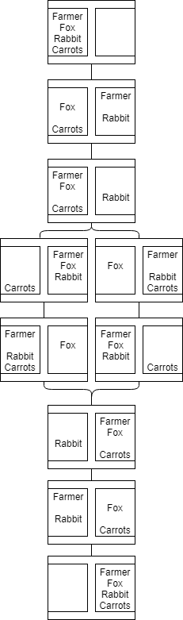Each node has left and right sides of the river, and entities listed in them. Constructed graph is an undirected graph that connects each step with possible steps. Graph can be undirected because, problem can be solved in reverse because it wouldn’t differ depending to side of the river. Invalid steps is not represented and a search algorithm used to find sufficent solution. In this case, BFS and DFS algorithms used.

2)Search Algorithm